|  |  |
| --- | --- |
| Name: | Prerna Sunil Jadhav |
| Sap Id: | 60004220127 |
| Class: | T. Y. B. Tech (Computer Engineering) |
| Course: | Information Security Laboratory |
| Course Code: | DJ19CEL603 |
| Experiment No.: | 09 |

**AIM:** Perform Information Gathering/ Footprinting.

1. **GOOGLE DORK:**
2. 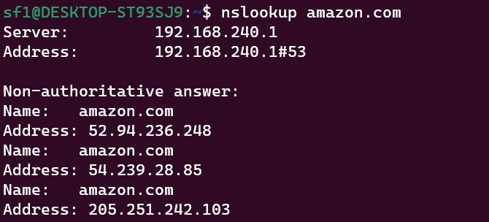**NSLOOKUP**

# SHODAN

# TRACERT

# WHOIS

